## REPORT OF THE ACTIVITIES OF THE NIGERIA ASSOCIATION OF ADVENTIST STUDENTS (NAAS), FUNAAB CHAPTER FROM 6TH MAY, 2024 TO 16TH JANUARY, 2025 PRESENTED AT THE ZONAL EXECUTIVE COUNCIL MEETING.

The Zonal President,

The Zonal ACM Director,

The Zonal Chaplaincy Director, The Zonal NAAS Executives Chapter Presidents,

Ladies and Gentlemen.

## OUTLINE

1. INTRODUCTION
2. ADMINSTRATION
3. PROGRAMMES HELD
4. FINANCIAL REPORT
5. STATISTICS
6. CHALLENGES
7. RECOMMENDATIONS
8. CONCLUSION

## INTRODUCTION

All thanks and praise to God for His unwavering faithfulness and abundant providence towards us. To Him alone be all the glory, now and always. Amen! This report highlights the activities and events of the Nigeria Association of Adventist Students, FUNAAB Chapter, from May 6, 2024, to January 17, 2025.

## ADMINSTRATION

These are the list of leaders that has been piloting the affairs of the chapter from the handing over.

|  |  |
| --- | --- |
| **NAMES** | **OFFICE** |
| LASISI MATTHEW ADEOLA | Executive President |
| KILANKO OLUWAFEMI | Vice President |
| KILANKO OLUWAFEMI | Sabbath school Coordinator |
| DADA RACHEL OLAJUMOKE | General Secretary |
| GOONEWS JEWEL | Treasurer |
| ALALA SUNDAY | Public Relations Officer |
| AJAYI TIMOTHY | Asst. Public Relations Officer |
| PST. OGUNSANYA SUNDAY | Chaper Pastor |
| GBODIMOWO ELIZABETH | Welfare Director |
| AHAM-ADI WINNER | Envagelism Coordinator |
| EMMANUEL PRECIOUS | Asst. Envagelism Coordinator |
| DADA RACHEL OLAJUMOKE | Music Director |
| OSUNSEYI OLUWATOBI | Financial Secretary |
| UGOSCHUKWU PRECIOUS | Asst. Sabbath school Coordinator |
|  |  |
|  |  |

## PROGRAMMES HELD

The Executives held a number of executive meetings both virtually and physically every first and third Fridays of every month and a general meeting holds every first Sunday of every month. Below is a list of activities held by members of the association this past semester;

|  |  |  |
| --- | --- | --- |
| **PROGRAMME** | **VENUE** | **DATE** |
| GENERAL MEETING | FELLOWSHIP CENTER | Regularly |

|  |  |  |
| --- | --- | --- |
| VISITATION/MEMBERS  CHECKUP | HOSTEL/ONLINE | Regularly |
| EXCOS PRAYER MEETING | FELLOWSHIP CENTER | Every sabbath |
| MIDWEEK/ EVAGELISM | INSIDE SCHOOL | Every wednesday/Friday |
| HOUSE FELLOWSHIP | ACTION UNIT CENTER | Every sabbath |
| COMMUNITY SERVICE | FELLOSHIP CENTER/CHARITY VILLA | 18|11|2024 and  31/11/24 |
| MATRICULATION | INSIDE SCHOOL (CEREMONIAL BUILDING) | 22|11|2024 |
| MY CAMPUS FOR CHRIST | ACTION UNIT CENTER | 30/11/24- 08/12/24 |
| PCM/ MEDICAL OUTREACH | INSIDE SCHOOL | 04/12/24 |
| FRESHERS SABBATH | FELLOWSHIP CENTER | 07/12/24 |
| INNUAGRAL LECTURE | CEREMONIAL BUILDING | 11/12/24 |
| FAMILY CAMP | CAMPSITE | 13/12/24- 15/12/24 |

Here’s a short breakdown of the programs listed in above, along with key achievements:

# Visitation/Members Checkup (House/Online) Frequency: Regularly

**Summary:** Personal outreach to members for encouragement, spiritual growth, and community bonding.

**Key Achievements:** Strengthened member relationships and improved participation in activities.

# EXCOS Prayer Meeting (Fellowship Center) Frequency: Every Sabbath

**Summary:** A prayer session for the executive members to seek guidance and blessings for the fellowship.

**Key Achievements:** Enhanced spiritual leadership and unity among

executives.

* 1. **Midweek Evangelism (Inside School) Frequency:** Every Wednesday

**Summary:** Outreach and evangelism activities aimed at spreading the gospel within the school community.

**Key Achievements:** Increased awareness of the gospel and new member enrollments.

* 1. **House Fellowship (Action Unit Center) Frequency:** Every Sabbath

**Summary:** Small group gatherings for Bible study, prayer, and worship.

**Key Achievements:** Strengthened spiritual growth and community spirit.

* 1. **Community Service (Fellowship Center/Charity Villa) Dates:** 18/11/2024 and 31/11/2024

**Summary:** Acts of service, and clearing of bushes within the community.

**Key Achievements:** Positive impact on the local community and increased fellowship visibility.

# Matriculation (Inside School - Ceremonial Building) Date: 22/11/2024

**Summary:** Participation in the school's matriculation ceremony to welcome new students.

**Key Achievements:** Established connections with new students and introduced them to the fellowship.

* 1. **My Campus for Christ (Action Unit Center) Dates:** 30/11/2024 - 08/12/2024

**Summary:** A week-long evangelistic program to win souls for Christ on campus.

**Key Achievements:** Significant spiritual impact and increased membership. We also had 2 souls won into the fold after the program.

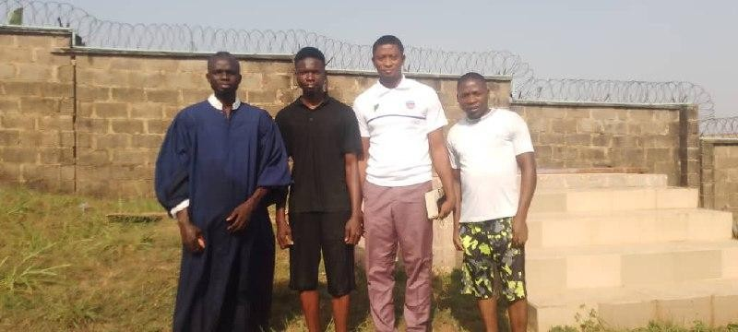

# PCM/Medical Outreach (Inside School) Date: 04/12/2024

**Summary:** Medical outreach providing free health services to students and staff.

**Key Achievements:** Enhanced community health and created goodwill for the fellowship. We had over 200 attendees.

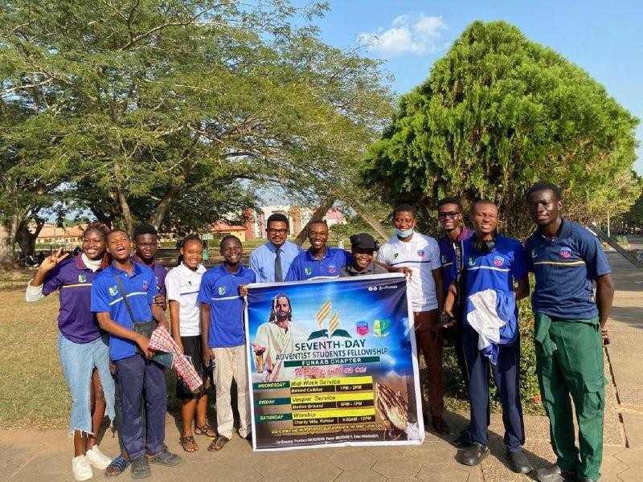

# Freshers Sabbath (Fellowship Center) Date: 07/12/2024

**Summary:** A special Sabbath service to welcome and celebrate new students.

**Key Achievements:** Increased engagement with new students and integration into the fellowship.

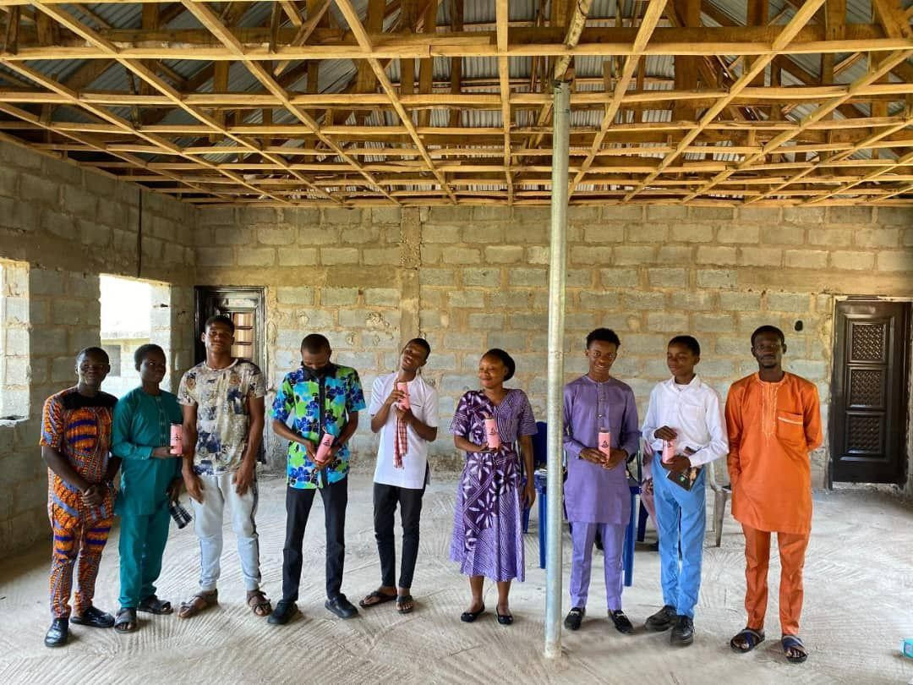

# Inaugural Lecture (Ceremonial Building) Date: 11/12/2024

**Summary:** A formal academic lecture for our sponsor ( Prof makinde) .

**Key Achievements:** Broadened intellectual horizon and visibility for the fellowship.

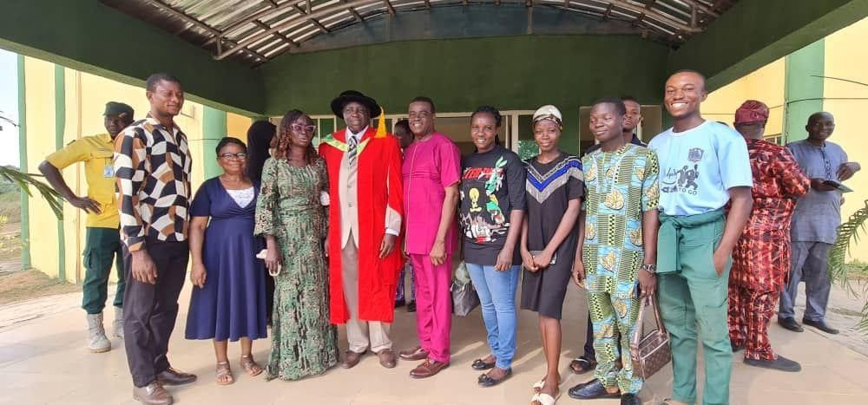

* 1. **Family Camp (Campsite) Dates:** 13/12/2024 - 15/12/2024

**Summary:** A retreat for members to relax, bond, and grow spiritually in a serene environment.

**Key Achievements:** Strengthened fellowship unity and provided spiritual rejuvenation. We also got to connect with other NAAS members across the zone.

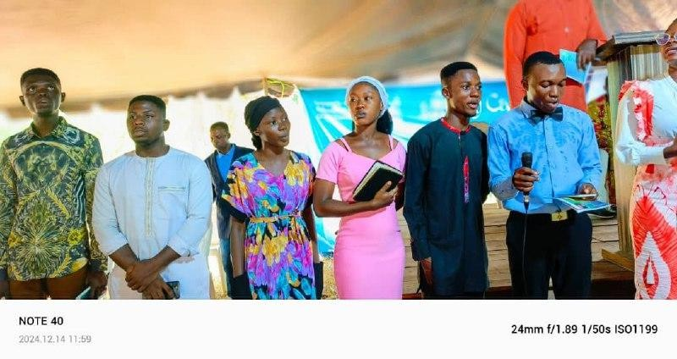

## FINANCIAL REPORT

**Financial report Income**

|  |  |  |
| --- | --- | --- |
| **Date** | **Description** | **Amount (#)** |
| **4/5/2024** | **Offering** | **400** |
|  | **Sabbath school** | **620** |
| **11/5/2024** | **Offering** | **200** |
|  | **Sabbath school** | **100** |
| **18/5/2024** | **Offering** | **800** |
|  | **Sabbath school** | **300** |

|  |  |  |
| --- | --- | --- |
| **25/5/2024** | **Offering** | **2,550** |
| **1/6/2024** | **Offering** | **4,300** |
| **8/6/2024** | **Offering** | **3,050** |
| **15/6/2024** | **Offering** | **1,300** |
| **22/6/2024** | **Offering** | **800** |

|  |  |  |
| --- | --- | --- |
| **29/6/2024** | **Offering** | **2,000** |
| **6/7/2024** | **Offering** | **1,050** |
| **13/7/2024** | **Offering** | **1,200** |
| **20/7/2024** | **Offering** | **800** |
| **27/7/2024** | **Offering** | **1,510** |
| **3/8/2024** | **Offering** | **2,550** |
| **10/8/2024** | **Offering** | **2,460** |

|  |  |  |
| --- | --- | --- |
| **14/8/2024** | **Support** | **5,000** |
| **14/8/2024** | **Support** | **5,000** |
| **15/8/2024** | **Support** | **10,000** |
| **17/8/2024** | **Offering** | **3,950** |
| **24/8/2024** | **Offering** | **1,040** |
| **31/8/2024** | **Offering** | **800** |
| **7/9/2024** | **Offering** | **650** |
| **14/9/2024** | **Offering** | **890** |
| **21/9/2024** | **Offering** | **650** |
| **28/9/2024** | **Offering** | **700** |
| **12/10/2024** | **Offering** | **950** |
| **19/10/2024** | **Offering** | **3,900** |
| **26/10/2024** | **Offering** | **5,950** |
| **2/11/2024** | **Offering** | **2,000** |

|  |  |  |
| --- | --- | --- |
| **9/11/2024** | **Offering** | **1,400** |
| **16/11/2024** | **Offering** | **2,650** |
| **18/11/2024** | **Offering** | **1,000** |

|  |  |  |
| --- | --- | --- |
| **23/11/2024** | **Offering** | **2,300** |
| **30/11/2024** | **Offering** | **1,850** |
| **7/12/2024** | **Offering** | **3,150** |
| **14/12/2024** | **Offering** | **500** |
| **21/12/2024** | **Offering** | **1,550** |
| **28/12/2024** | **Offering** | **400** |
| **4/01/2024** | **Offering** | **1,800** |
| **11/01/2024** | **Offering** | **1,950** |
|  |  | **Total= 86,020** |

**Expenditure**

|  |  |  |
| --- | --- | --- |
| **Date** | **Description** | **Amount (#)** |
| **8/5/2024** | **Zone percentage of naas offering** | **4,350** |
| **19/8/2024** | **Purchase of herbicide for fellowship site** | **4,200** |
| **20/10/2024** | **Purchase of household materials for bible worker** | **6,300** |
| **7/12/2024** | **Freshers Sabbath** | **12,000** |
|  |  | **Total= 26,850** |

**BALANCE = TOTAL INCOME - TOTAL EXPENDITURE**

**= 86,020 - 26,850**

**= 59,170**

## STATISTICS:

The membership dynamics of the FUNAAB chapter are quite unique, as attendance and participation often depend on the nature of the programs held. With over 50 registered members and 30 actively involved ones, the chapter continues to thrive within the campus community. While there are over 100 Adventist students on campus, efforts are ongoing to engage more students and strengthen their connection to the association.

## CHALLENGES

There are numerous challenges encountered in Babcock Chapter. Some of which includes;

* Financial Support for programs and Project
* Building Project
* Inability of student to identify with the fellowship.
* School fees and accommodation for some students.

## RECOMMENDATIONS

We encourage this administration to maintain strong connections with all universities within this zone where NAAS is present. Collaborative efforts in raising awareness about NAAS will not only strengthen inter-university relationships but also help grow the association's membership base.

1. **CONCLUSION**

We are inspired to keep making an impact and shining our light wherever we are placed. Trusting in the assurance of Isaiah 40:31, "But those who wait on the Lord shall renew their strength; they shall mount up with wings like eagles, they shall run and not be weary, they shall walk and not faint," we are strengthened to achieve even greater things for His glory.